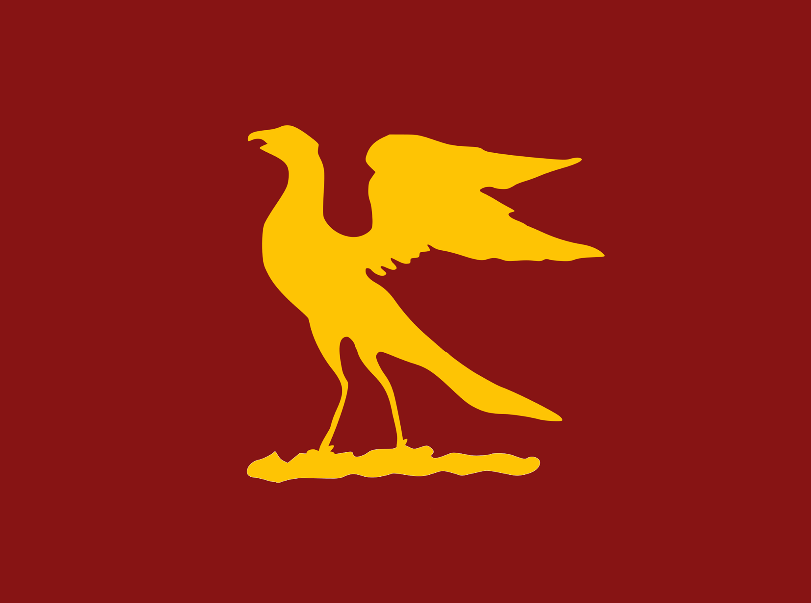 **Hawks & Ospreys Charitable Trust**

**Tutor Confirmation**

I confirm as the candidate’s Tutor that the candidate is a member of College, that to the best of my belief the applicant’s circumstances are as described above and that they are an appropriate recipient of a Hawks and Ospreys Charitable Trust award.

Name: …………………...…………………….………………………………………

Email: …………………………………………………………………………………

Signature: ...………………………………………………… Date:………………………….